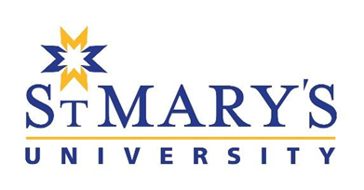
StMU ACADEMIC PUBLIC LECTURE - NOMINATION

Nominate an academic you know to come to StMU to give a PUBLIC lecture in their given area of expertise. StMU aims to host ONE lecture likely in October/November of 2026. Speakers’ travel, accommodation, and meal costs will be covered and an honouriam provided. Faculty are encouraged to recommend individuals (international applications are welcome!) they believe would be interested and a good fit*.
Deadline: June 5th, 2026
To apply, send a completed application (as a pdf) to Director of Research, corinne.syrnyk@stmu.ca
- Name of nominee, degree(s), field, current institution:
- Link to nominee’s professional website:
- Brief description of how nominee’s expertise relates to StMU programming and/or initiative and/or mission (300 word MAX):
- Title and brief description of possible public lecture (300 word MAX):
Nomination must include as separate attachments:
Copy of nominee’s CV

*Note: Goodness of fit based on faculty expertise in relation to StMU programming and/or initiative and/or mission.

